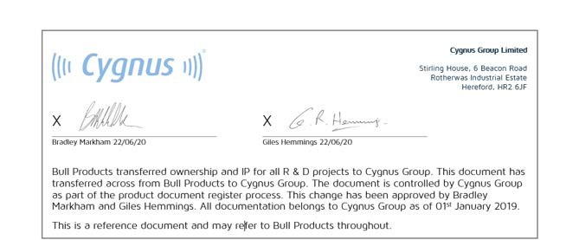

|  |  |  |  |  |  |
| --- | --- | --- | --- | --- | --- |
| **BULL PRODUCTS LTD**  **Cygnus SmartNet DETECTORS**  **DETAILED SPECIFICATION**  **January 2018** | | | | | |
| **Document No: 1000-SPC-0003** | | **Client Ref:** | | | |
|  |  |  |  |  |  |
|  |  |  |  |  |  |
|  |  |  |  |  |  |
|  |  |  |  |  |  |
|  |  |  | Wen | dy Digita Wend | lly signed by y Lefevre |
|  |  |  | Lefe | vre Date: 16:25: | 2019.05.08  00 +01'00' |
|  | New command added and updated information | 17 Jan. 18 | RM | RM | RM |
|  | Updated information on various specification | 06 Oct. 17 | SG | SG | RM |
|  | First Issue | 21 Aug. 17 | GH |  |  |
|  | **Description** | **Date** | **Prep** | **Chk’d** | **Apprv’d** |
| **HARD COPIES ARE UNCONTROLLED**  Controlled copies of this document are only issued in the PDF format that includes digital signatures of the author, checker and approver. These signatures can be viewed in Adobe Acrobat. The document will be digitally marked if it has been altered since signing. In order for recipients of documents to verify digital signatures, digital signature certificates may be requested from Bull Products Ltd. | | | | | |

**REVISION HISTORY**

|  |  |  |
| --- | --- | --- |
| **Revision** | **Pages** | **Description** |
| 01 | All | New document |
| 02 | 6,7,10,11,12  ,18, 36,37 | Updated Power Supply specification due to battery technology change. Class of Device Command and Added New Enable/Disable command  Serial number format defined |
| 03 | 38, 45 | Example 1 for “;EDXX” command updated. New command “Branding Id” added. |

**CONTENTS**

1. INTRODUCTION 5
   1. Conventional Detectors 5
   2. Analogue Addressable Detectors 5
2. ANALOGUE ADDRESSABLE DETECTORS 6
   1. Product Range 6
   2. Electrical Specification 6
   3. Mechanical 8
   4. Detector Specification Tables 10
   5. Protocol Specification 10
3. CONVENTIONAL DETECTORS 14
   1. Mechanical 14
   2. Electrical 15
4. COMMON CHARACTERISITICS FOR ALL DEVICES 17
   1. Mechanical Data 17
   2. Mechanical Specification [Updated] 17
   3. Dust Covers [Updated] 20
   4. Compliance 20
   5. Marking Specifications 21
   6. Technical Construction File (TCF) 25
   7. Review & Document Change Control Procedure 25
5. EXTERNAL INTERFACES & TOOLS 26
   1. Detector Removal Tool 26
6. GENERAL DESIGN STANDARDS 27
7. DETECTOR PROTOCOL SPECIFICATION 28
   1. Introduction 28
   2. Operation of the Interface 28
   3. Base Waking up Detector 30
   4. Detector Waking up Base 31
   5. States of Operation 31
   6. Communication Port Settings 33
   7. General Command Syntax 33
   8. Error Handling 34
   9. Set of Commands 34
8. REFERENCES 47

**LIST OF FIGURES**

Figure 1 - Detector Head Pin-out 8

Figure 2 - Detector Ranges 11

Figure 3 - Detector Head Pin-out 14

Figure 4 - Detector Base Showing Screw Terminals 15

Figure 5 - Switched Output Schematic 16

Figure 6 - Detector Alignment Marks 17

Figure 7 – Lock Pin Release Access Hole 18

Figure 8 - Base Locking Mechanism 18

Figure 9 - Embossed Branding Positions 19

Figure 10 - 'Do Not Paint' Text Location 20

Figure 11 - Detector Base Photo 23

Figure 12 - Detector Base 2D Drawings (Top Side - Left, Bottom Side – Right) 23

Figure 13 - Screw Terminal Locations 24

Figure 14 - Both Units in Sleep 28

Figure 15 - Detector gets the attention of the Base 29

Figure 16 - Base gets the attention of the Detector 29

Figure 17 - Interaction between Base and Detector 30

Figure 18 Detector State changes 32

# LIST OF TABLES

Table 1: Analogue Addressable Detector Product Range 6

Table 2: Pinout Description 7

Table 3 – Detector Specification Matrix 10

Table 4 – Common Specifications Between All Detectors 10

Table 5 - Reported Error Values 12

Table 6: Pinout Description 15

Table 7 - Numens Part Numbers 24

Table 8 - Pin-Out 24

Table 9 - States of Operation of Attached Device 31

Table 10 - Communication Port Settings 33

Table 11 – Type of Devices 35

Table 12 - Smoke detector class 36

Table 13 - Smoke detector + PIR class 36

Table 14 - Heat detector class 37

Table 15 – Smoke + Heat detector class 37

Table 16 Sensor Types and IDs 38

# INTRODUCTION

A range of fire detection devices / detectors and fire related actuators are being developed for Bull Products Ltd. All units are specified to operate as a part of the wireless and battery-operated fire detection system designed and manufactured by Bull Products Ltd. Some common characteristics for such devices are itemized in the following paragraph.

Detectors consist of two types; Conventional and Analogue Addressable.

# Conventional Detectors

Numens already produce conventional detector heads. Numens will modify the design of the pin connector arrangement on the base of the detector to mate with the new BPL connector design. A separate section details the conventional detector specification.

# Analogue Addressable Detectors

BPL are developing wireless radio bases for the Analogue Addressable detectors. Numens will design detector heads which can interface to the BPL radio bases using the same connector design. As the Analogue Addressable detectors are powered from a long-life battery, Numens will re-design the power supply circuitry to run at a lower voltage and very low current to maximise operating life.

This document will cover both device types in three sections. A separate section covers specifications common to Conventional and Analogue Addressable detectors.

# ANALOGUE ADDRESSABLE DETECTORS

All aspects of the Analogue Addressable detector range are described in this section. A separate section covers specifications common to both Conventional and Analogue Addressable detectors.

# Product Range

All detectors will be of the analogue addressable type and should be of modular design, detachable from the radio base unit. Although Radio base units are being developed by BPL, they will use the mechanical features which Numen’s designed for the BPL standard base, so it can accept Numens detectors and other BPL devices.

The following tables show the complete product range in scope of the Numens Analogue Addressable detector development. Further details for each component are provided in this document.

|  |  |  |  |  |
| --- | --- | --- | --- | --- |
| **Permanent Installation Component** |  | **New Bull Products Part Number** | **Previous Part Number** | **EN54 Compliance Requirements** |
| Heat Detector (A1R) |  | HD01 | HD30 | EN54-5 |
| Heat Detector (B) |  | HD11 | HD301 | EN54-5 |
| Smoke Detector |  | SD01 | SD40 | EN54-7 |
| Smoke + Heat Detector (A1R) |  | MS01 | SHD50 | EN54-5 + EN54-7 + EN54-29 |
| Smoke Detector + PIR |  | MS11 | SDP60 | EN54-7 |

**Table 1: Analogue Addressable Detector Product Range**

# Electrical Specification

* + 1. **Pin Functional Description [Updated]**

A 4 pin interface is used for power and data interface to the detector. A detector always has four pin sockets. The four mating pins will be located on the radio PCB in order to interface to the detector, the pinout is as follows:

|  |  |  |  |  |  |  |  |  |
| --- | --- | --- | --- | --- | --- | --- | --- | --- |
| **Pin Label on Device**  **Plastics** | **Function** | **Description** | **Active** | **VIL** | **VIH** | **VOL** | **VOH** | **IIN** |
| P+ | +3.6V | Positive Supply pin | - | 2.5 | 3.8 | - | - | 18mA |
| A | Data Tx | 2.2V UART | High | - | - | 0.4 | 1.8 |  |
| B | Data Rx | 2.2V UART | High | 0.46 | 1.84 | - | - |  |
| P- | GND | Ground pin | - | - | - | - | - |  |

# Table 2: Pinout Description

Voltage Level Notes:

VOL Maximum output voltage when the output level is a logic “0” for the Tx line VOH Minimum output voltage when the output level is a logic “1” for the Tx line VIL Maximum input voltage which can be interpreted as a logic “0” for the Rx line VIH Minimum input voltage which can be interpreted as logic “1” for the Rx line

These lines are CMOS Rx and Tx line of the MCU UART (Inverted logic RS232).

# Power Supply [Updated]

Each detector will have its own on-board PSU (designed by Numens) converting the device input voltage of 2.5V (minimum usable battery voltage) to 3.8V (maximum battery voltage) from the radio base. The max battery voltage is theoretical and must have sufficient overhead factored in for battery pack voltage variance.

Unregulated battery voltage is passed from the radio base through to the Detector. Numens must design their own linear regulator circuit for the detector. Due to the detectors being very low power during sleep, a PSU must be chosen which has a very low quiescent current (Iq) and high efficiency with trade-off against low-cost (consideration must be given to linear voltage regulators due to their low Iq, low cost and low-noise properties). It is important that the PSU is most efficient at low currents (e.g. when idle and in Tx/Rx). High current efficiency is less important as alarm mode is infrequent.

All the detectors or actuators should operate in the common DC voltage range of: Min. Operating Voltage: ≤ 2.5 V

Max. Operating voltage: ≥ 3.8V

Max. Current (operating - when in alarm mode)1: ≤ 30mA (at 3.8V), with both LEDs enabled

Max. Quiescent Current (operating - not in alarm mode) 1: ≤ 6 µA

# Pull-Down Resistor [Updated]

A pull-down resistor (R44 as shown) must be provided on the detector PCB Receive line, to ensure that the pin does not float. This will be a 3M-Ohm resistor.

1 Those values are general maximum values which apply only if the same parameter is not defined for the specific device

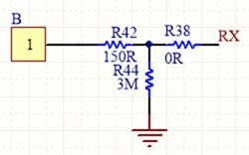

# Circuitry provided by Numens

* + 1. **Detector Reset Function**

The detector shall have a reset function, this may be controlled by the radio base MCU via a load switch (i.e. FET Transistor) with negligible series resistance when the detector is powered on. The radio base switches off the power supply to the detector for a pre-determined time to allow for detector reset. Reset time = <30 seconds.

When a detector is in alarm state, it cannot be reset without a power cycle. All Numens detectors will be reset from the radio base.

# Mechanical

* + 1. **Pin Positions Diagram**

The pin layout has been designed to suit the BPL requirement for PCB mounted contacts on the detector. The base has four PCB pins (spades) and the detector head has four sockets.

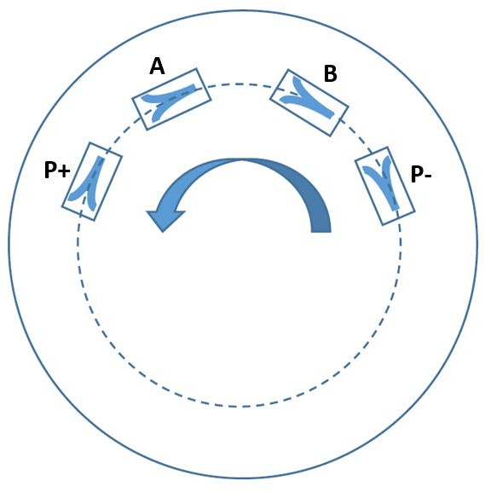

**Figure 1 - Detector Head Pin-out**

The pin numbering is specific to the Analogue Addressable detectors. Functions of the pins are described in Table 2.

# Detector Pin Enclosure Markings

For the Analogue Addressable detector enclosures, pin description text will be printed (no mould markings required), as shown below.

Analogue Addressable: P+ A B P- Text location is shown in Figure 1

# Detector Mesh Screen

Where a screening mesh is used to protect and allow air flow to the sensor, this must be manufactured from a non-metallic material due to potential RF blocking of the Analogue Addressable signals from the radio base. Mesh hole sizes will be optimal for air flow to the sensor specification.

# Mutual Interference

Consideration must be given to the location of screws and other metal parts with the enclosure design effecting antenna RF performance in the radio base. Where possible, plastic clips must be used to minimise detuning effects.

As the detector and the radio base are designed to be co-located together, care must be taken to prevent interference between them. Numens will work closely with Bull Products to resolve any performance issues related to close-proximity of the two devices.

BPL will have an RF antenna solution optimised and tuned to the frequency band being used by the radio base. During functional testing, pre-compliance testing and if RF compatibility issues arise, Numens and BPL may need to work together with regards to the location of any metal parts in the detectors both Numens and BPL components will be tested together.

# Detector Specification Tables

The following tables show a summary of the detector requirements for each detector type.

* + 1. **Detector Specification Matrix**

|  |  |  |  |  |  |
| --- | --- | --- | --- | --- | --- |
| **Parameter** | **Detector** | | | | |
| **Heat A1R** | **Heat B** | **Smoke** | **Smoke +**  **Heat** | **Smoke + PIR** |
| BPL Part No. | HD01 | HD11 | SD01 | MS01 | MS11 |
| EN54 Compliance | EN54-5 | EN54-5 | EN54-7 | EN54-29 | EN54-7 |
| Average  Quiescent current | 6uA | 6uA | 6uA | 6uA | 6uA |
| Average current  in alarm condition | 18mA | 18mA | 18mA | 18mA | 18mA |
| Rate of Rise (RoR) | EN54-5  Class A1R | NA | NA | EN54-5  Class A1R | NA |

**Table 3 – Detector Specification Matrix**

* + 1. **Common Specification**

|  |  |
| --- | --- |
| **Parameter** | **Requirement** |
| Subtype | Analogue addressable (with a fixed address), Resettable |
| Number of pins | 4 |
| Indication LED | RED |
| Start-up time | ≤ 30 s |
| Reset Time | ≤ 30 s |
| Self-test | Yes – Special function initiated by the base unit |
| Analogue value | On demand and when the value increases above the  programmable threshold values are reached |
| Pre-Alarm | When the detector reaches the pre-defined pre-alarm level, it  wakes the radio base and passes its current value. |
| Alarm | When the detector reaches the pre-defined alarm level, it wakes- up the radio base allows its current value to be read. The radio  base sends this data to the CIE. |
| LED operation | The LED is controlled by the radio base. |
| Read sensor alarm status | On demand from base unit to confirm if the unit is still in alarm or  not |

**Table 4 – Common Specifications Between All Detectors**

# Protocol Specification

See section 7 for the protocol specification.

# Analogue Value Ranges [Updated]

Detectors report values in the range of 0 to 99, each being an analogue value. There are different values for Smoke and Heat described in the diagrams below.

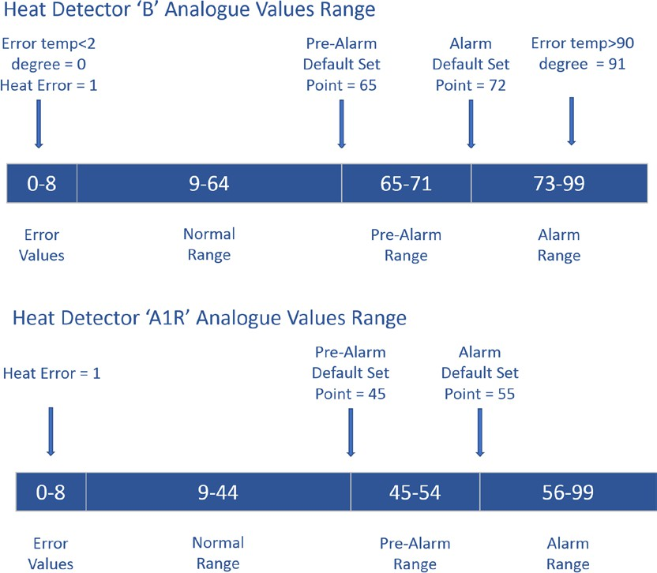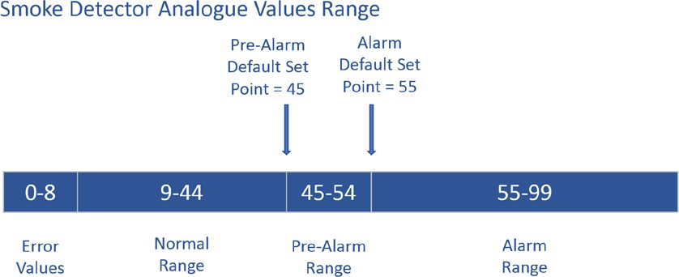

# Figure 2 - Detector Ranges

The Normal, Pre-Alarm and Alarm ranges are analogue values which vary depending on the amount of heat/smoke in the sensor.

# Error Values [Updated]

The Error values range consist of values which correspond to different error states, as described in the table below. The error codes are part of the analogue range of values. If an error is found, the value is read.

|  |  |  |  |
| --- | --- | --- | --- |
| **Error**  **Value** | **Description** | **Heat Detector** | |
|  |  | **Type A1R** | **Type B** |
| 0 | N/A |  | Temp < 2degree |
| 1 | Faulty Sensor | Heat error | Heat error |
| 2 | Dirty Sensor |  |  |
| 3 | Faulty & Dirty Sensor |  |  |
| 4 | Internal Fault |  |  |
| 5 | N/A |  |  |
| 6 | N/A |  |  |
| 7 | N/A |  |  |
| 8 | Internal Fault |  |  |
| 91 | N/A | N/A | Temp > 90 degree |

**Table 5 - Reported Error Values**

* + 1. **Special Test Modes**

**Self-test function**

The detector shall provide means of determining the contamination status of the optical chamber status as a 2-bit value. The following list describes the returned value:

* + - 1. – Optical Chamber Normal (default value)
      2. – Not Used (normally Dirt Low Level, but it is difficult to define contamination as there is no reference to the current environment effects)
      3. – Dirt Med Level
      4. – Faulty

# LED test

The detector shall provide means of testing the operation of the LEDs (visual inspection). This can be achieved by sending a command to activate LED.

# Sensor Self-Test

The detector shall monitor its operation regularly and detect any possible faults by following the steps described below:

1. The detector tests the sensor for faults every 4 seconds.
2. If a value is out of range, it tests for faults again for up to 9 more times.
3. If the value is back in range within these 10 tests, then the sensor is classed as normal and no fault is logged (this is repeated continuously).
4. If found to be faulty, it logs a fault value. The radio base then reads the fault when it next talks to the detector.

# Manufacturers Adjustment/Calibration for Optical Smoke Detectors

There is no manufacturers adjustment scheme. The sensitivity compensation scheme (drift calibration) used is from EN54-7, Annex L. This is to overcome sensor sensitivity changes over time due to dirt in the optical smoke sensor.

# CONVENTIONAL DETECTORS

Numens have developed a line of conventional detects as their core product. BPL have requested changes to be made to the pin connector system and the locking mechanism. The functional electronics remain the same as the current conventional detectors, but the enclosure is changed to suit the design for the BPL Analogue Addressable detectors.

# Mechanical

* + 1. **Conventional Detector Pin Positions**

The pin layout has been designed to suit the BPL requirement for PCB mounted contacts on the detector. The detector head has four PCB socket locations, but only three are used, and text must be printed as follows;

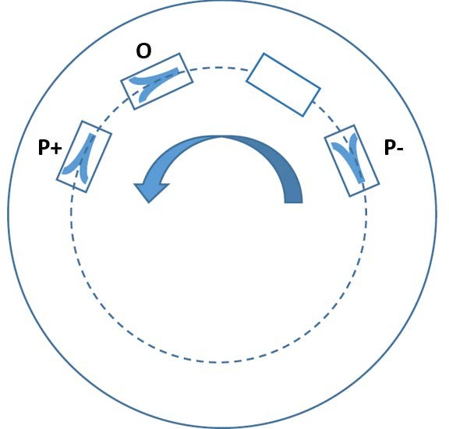

# Figure 3 - Detector Head Pin-out

One of the pins is shown as a blank location on the diagram above. This spare pin is used for use with the Analogue Addressable detector product range.

See the Pin Description in the Common Features section for further information.

# Detector Pin Enclosure Markings

For the Analogue Addressable detector enclosures, pin description text will be printed (no mould markings required).

The printed text will be:

Conventional Detectors: P+ O ‘ ‘ P-

Note: (‘ ‘ means no marking as there is no pin in this position).

# Electrical

* + 1. **Pin Functional Description**

A common 4 pins interface is used for all, where the pinout is as follows:

|  |  |  |  |  |  |  |  |  |
| --- | --- | --- | --- | --- | --- | --- | --- | --- |
| **Pin Label on Device**  **Plastics** | **Function** | **Description** | **Active** | **VIL** | **VIH** | **VOL** | **VOH** | **IIN** |
| P+ | V input | Positive Supply pin | - | 3 | 12 | - | - | 25 mA |
| O | Output | Open Collector  Output | Low | 0 | P+ | - | - |  |
| Blank (B) | Unused – no pin  present |  | - | - | - | - | - | - |
| P- | GND | Ground pin | - | - | - | - | - |  |

# Table 6: Pinout Description

A detector always has three pin sockets. The three mating pins are present on the base and interface to the wiring through screw terminals. The power pins ‘P+’ and ‘P-‘ and the open-collector output pin ‘O’ would be required to provide power to the detector and sense when its digital output changes. Output ‘O’ could connect to a sounder or visual beacon, for example.

Note: the output pin will be labelled as A/O on the base.

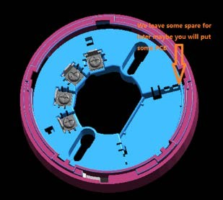

# Figure 4 - Detector Base Showing Screw Terminals

* + 1. **Detector Power Supply**

Each detector will have its own on-board PSU (designed by Numens) converting the power from the detector base terminals, supplied by the BPL battery packs in the current BPL Cygnus-I system. All the detectors or actuators should operate in the common DC voltage range of:

Min. Operating Voltage: ≤ 3.0V

Max. Operating voltage: ≥ 12V

Max. Current (operating - when in alarm mode)1: ≤ 25mA (with both LEDs enabled) Max. Quiescent Current (operating - not in alarm mode) 1: ≤ 8µA

# Switched Output

A switched output will be provided on pin ‘O’. This is an open-collector output from an NPN transistor within the detector. The transistor shall be able to drive loads of up to 20 mA DC constant current and a voltage of up to 50 VDC. The connected device will have the pull-up resistor fitted.

If used with a sounder or VAD, the GND of the device will connect to the ‘O’ pin (low-side switching). The device selected must comply with the load limits specified above.

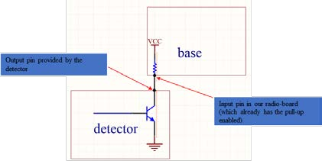

# Figure 5 - Switched Output Schematic

The transistor used is a 2SC1623 NPN type. The transistor can sink 20mA, 150mW and the maximum collector voltage is 50V.

# Reverse Voltage Polarity Protection (RVP)

There must be RVP in case the user connects the power incorrectly. The RVP circuit must have a very low voltage drop (i.e. not just a series diode).

# Visual Indicators

A powered visual indicator shall be visible from a distance of 6m directly below the detector, in an ambient light intensity up to 500 lux, as per EN54 standards. There must be two LEDs and both must be mounted through the enclosure so they are physically visible when off. LED’s must also be visible from across a room in direct view, so a raised LED or light pipe is preferred.

|  |  |
| --- | --- |
| LED colour | Red |
| Light pipe colour | Clear lens with raised and exposed dome (allowing light to be seen from an angle) |
| LED functionality | ON (Steady light) - when activated by radio base during alarm condition  OFF - when in Normal state AND  - when de-activated by radio base after panel reset. |

Note: The LEDs must not be hidden behind thin plastic.

# COMMON CHARACTERISITICS FOR ALL DEVICES

Bull Products fire detection system is designed to comply with European EN54 standards and all its affiliated parts. All components made for the system should either individually comply with the relevant parts of the standards, where required, or to be designed to enable the whole of the system to comply with it.

# Mechanical Data

All 2D drawings and 3D CAD model files shall be provided for the standard detector base, drawing number 2705001-0007, so that BPL can make changes for incorporation of other products. All mechanical features must be provided in the CAD file (such as the locking mechanism, etc.).

# Mechanical Specification [Updated]

* + 1. **Enclosure Materials**

Plastic enclosure parts spec: ABS

# Enclosure Colours

White parts: RAL 9003

Enclosure Textured Finish: Shiny/ Gloss finish (VDI=0)

# Enclosure Colours

PIR Lens spec (this is free-issued part by BPL) **– Panasonic** EKMB1301111 wired directly on the detector PCB. Refer to [1] for detailed specification of the PIR part.

# Detector Head Fitment

Twist-lock system where the detector is aligned with the ‘open’ markings and then turned clockwise until it locks in position. Removal is the reverse of fitment. During fitment, the three/four electrical contacts will mate to produce a secure electrical connection to the detector base.

Plastic moulded markings must be present on the sides of the base and detector head to allow for ease of alignment. Two markings of varied sizes must indicate alignment of ‘locked’ and ‘unlocked’ positions (see photo below).

See drawing for size and position.

The short marking on the detector indicates the unlocked position. The long marking on the detector indicates the locked position.

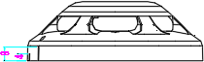

# Figure 6 - Detector Alignment Marks

See drawing numbers 2705001-0001, 2705001-0002, 2705001-0003 and 2705001-0010.

# Detector Head Fitting/Removal – User Experience

To ensure the best user experience for the installation engineer and user, the detectors must have smooth bayonet fitting which is easy to turn and lock into position without excessive force.

This is important when the detector head is removed from the radio base at height where a removal tool must be used. A smooth low-torque mechanism will aid fitment and removal.

# Removal Locking Mechanism [Updated]

A locking mechanism will be provided in the base to prevent opportune removal of the detector from the base. The detector hole must allow access to the locking mechanism and must be of diameter 3.3 mm (clear, not threaded).

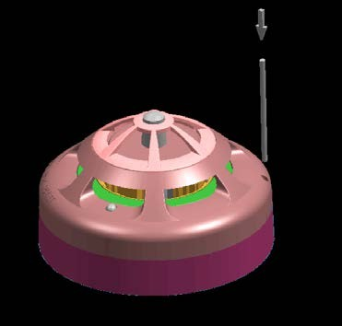

# Figure 7 – Lock Pin Release Access Hole

For the detector head access hole, see drawing numbers 2705001-0001, 2705001-0002, 2705001- 0003 and 2705001-0010.

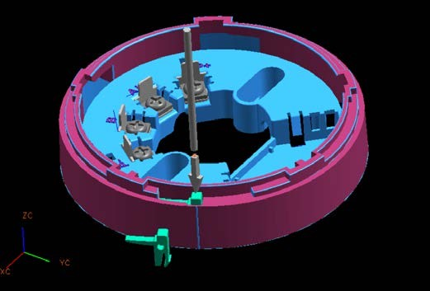

# Figure 8 - Base Locking Mechanism

For the conventional base manufactured by Numens, the locking mechanism will be a push-lock, which is easily accessible during maintenance using a tool. The lock simply prevents the detector from being turned anti-clockwise and will consist of a sprung latch, accessible from a hole on the top of the detector. The user will insert the tool into the hole and push to release the lock, while turning the detector to the unlock position. See drawing numbers 2705001-0007.

# Embossed Branding [Updated]

Bull Products require branding on the front face of the detectors. The words ‘Cygnus’ and ‘SmartNet’ are required to be embossed on to the faces of the detectors as shown in Figure 9.

The entire “Cygnus” and “SmartNet” Logos is 20mm width.

DXF file name : 7482_Cygnus_Smartnet_Blk_2pt_20mm_OUTLINE

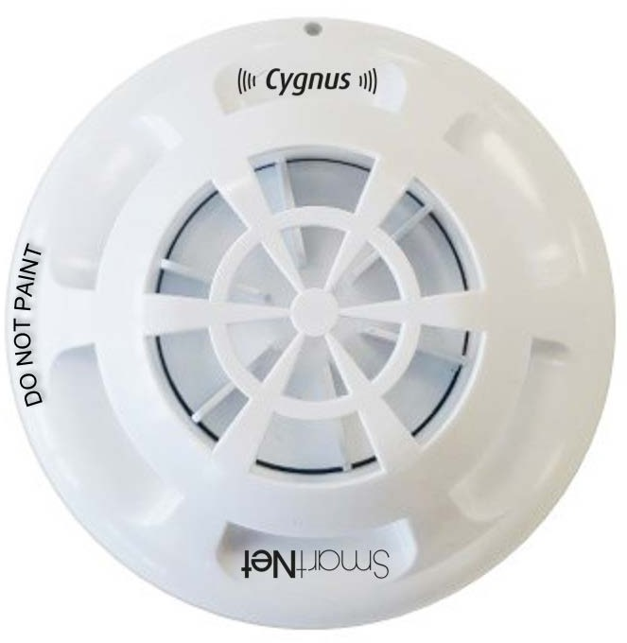

# Figure 9 - Embossed Branding Positions

* + 1. **Ingress Protection**

The enclosure should be designed with ingress protection, preventing unwanted foreign bodies from entering the enclosure and sensor. There will be natural build-up of dirt on the sensor over time, which is calibrated out on reset (this can be ignored).

The detector shall be designed so that a sphere of diameter (1.3 ± 0.05) mm cannot pass into the smoke sensor chamber(s).

# User Readable Text

Plastic moulded text must be shown on the top surface of the head stating, “DO NOT PAINT”. See drawing for text size, font and location (see photo below).

Numens will provide the current design of text specification, font, size, character spacing and location.



# Figure 10 - 'Do Not Paint' Text Location

See drawing numbers 2705001-0001, 2705001-0002, 2705001-0003 and 2705001-0010 for detail.

# Dust Covers [Updated]

Each detector must be packaged with a dust cover fitted to protect the detector from dust ingress during installation. There are two types of dust cover to fit to the range of detectors:

1. Low-profile dust cover – To fit ‘Smoke Only’ detectors and ‘Heat Only’ detectors.
2. High-profile dust cover – To fit ‘Smoke + Heat’ detectors and ‘Smoke + PIR’ detectors.

Dust covers must be similar in design and material to the current Numens range of dust covers.

# Compliance

Compliance will be carried out to all of the required standards to ensure the system meets EN54. Analogue Addressable Detectors: BPL will be responsible for testing to EN54 by a notified body in a UK test house.

Conventional Detectors: Numens will be responsible for testing to EN54 by a notified body. ***BPL may*** ***provide an interface box to connect the detector during testing.***

# EN 54 spec requirements

Each detector type will conform to the relevant BS EN54 British Standards and the standards called up within these documents.

Numens are required to provide responsive support to BPL during the compliance process of the radio base to ensure smooth certification.

# Ratiometric Testing [Updated]

For the detectors to be compliant with EN54, a ratiometric test will be carried out to ensure that the detector output does not vary with supply voltage fluctuation.

# Environmental requirements – hot, cold, humidity

All detectors will conform to the upper and lower temperature and humidity specification listed in the EN54 standards.

# EMC emissions and immunity requirements, RED specs

All detectors will conform to the EMC and RED specification listed in the EN54 standards.

Numens are required to provide support to BPL if any RF or EMC issues arise during radio base testing.

# Shock, Impact, Vibration

All detectors will conform to the shock, vibration and impact testing specification listed in the EN54 standards.

# Corrosion Specification

All detectors will conform to the corrosion specification listed in the EN54 standards.

# Marking Specifications

The enclosure parts must have printed markings and must contain the following information according to the EN54 guidelines. The guidelines for each detector type are listed below:

# Heat Detector Marking

The following marking specification for heat detectors has been taken from the EN54-5:2000 standard (see page 8).

Each detector shall be clearly marked with the following information:

* + - 1. the number of this standard (i.e. EN 54-5 and EN54-25);
      2. the class(es) of the heat detector (e.g. A1, A1R, A1S, A2, B etc.). If the heat detector has provision for on-site adjustment of the class (see 4.8), then the marking of the class may be replaced by the symbol P;
      3. the name or trademark of the manufacturer or supplier;
      4. the model designation (type or number);
      5. some mark(s) or code(s) (e.g. serial number or batch code), by which the manufacturer can identify, at least, the date or batch and place of manufacture, and the version number(s) of any software contained within the detector. ***This format is to be confirmed by BPL.***

Notes:

Where any marking on the device uses symbols or abbreviations not in common use then these shall be explained in the data supplied with the device.

The marking shall be visible during installation of the detector and shall be accessible during maintenance.

The markings shall not be placed on screws or other easily removable parts.

# Optical Smoke Detector Marking

The following marking specification for heat detectors has been taken from the EN54-7:2000 standard (see page 10).

Each detector shall be clearly marked with the following information:

* + - 1. the number of this standard (i.e. EN 54-7 and EN54-25);
      2. the name or trademark of the manufacturer or supplier;
      3. the model designation (type or number);
      4. some mark(s) or code(s) (e.g. serial number or batch code), by which the manufacturer can identify, at least, the date or batch and place of manufacture, and the version number(s) of any software contained within the detector. ***This format is to be confirmed by BPL.***

Notes:

Where any marking on the device uses symbols or abbreviations not in common use then these shall be explained in the data supplied with the device.

The marking shall be visible during installation of the detector and shall be accessible during maintenance.

The markings shall not be placed on screws or other easily removable parts.

# Multisensor (Optical Smoke & Heat) Detector Marking

The following marking specification for heat detectors has been taken from the EN54-5:2000 standard (see page 8) and EN54-7:2000 standard (see page 10).

Each detector shall be clearly marked with the following information:

* + - 1. the number of this standard (i.e. EN 54-25 and EN54-29);
      2. the class(es) of the heat detector (e.g. A1, A1R, A1S, A2, B etc.). If the heat detector has provision for on-site adjustment of the class (see 4.8), then the marking of the class may be replaced by the symbol P;
      3. the name or trademark of the manufacturer or supplier;
      4. the model designation (type or number);
      5. some mark(s) or code(s) (e.g. serial number or batch code), by which the manufacturer can identify, at least, the date or batch and place of manufacture, and the version number(s) of any software contained within the detector. ***This format is to be confirmed by BPL.***

Notes:

Where any marking on the device uses symbols or abbreviations not in common use then these shall be explained in the data supplied with the device.

The marking shall be visible during installation of the detector and shall be accessible during maintenance.

The markings shall not be placed on screws or other easily removable parts.

# Optical Smoke Detector with PIR Marking

The following marking specification for heat detectors has been taken from the EN54-7:2000 standard (see page 10).

Each detector shall be clearly marked with the following information:

* + - 1. the number of this standard (i.e. EN 54-7 and EN54-25);
      2. the name or trademark of the manufacturer or supplier;
      3. the model designation (type or number);
      4. some mark(s) or code(s) (e.g. serial number or batch code), by which the manufacturer can identify, at least, the date or batch and place of manufacture, and the version number(s) of any software contained within the detector. ***This format is to be confirmed by BPL.***

Notes:

Where any marking on the device uses symbols or abbreviations not in common use then these shall be explained in the data supplied with the device.

The marking shall be visible during installation of the detector and shall be accessible during maintenance.

The markings shall not be placed on screws or other easily removable parts.

Numens will provide the drawings for label design and text location for approval by BPL. Note: the above list is subject to change.

# Base drawing

The Numens base design will be used for the conventional detector range. BPL will modify the 3D CAD file to design a new base which can house the radio PCB and battery.

Numens will provide the Conventional base drawing.

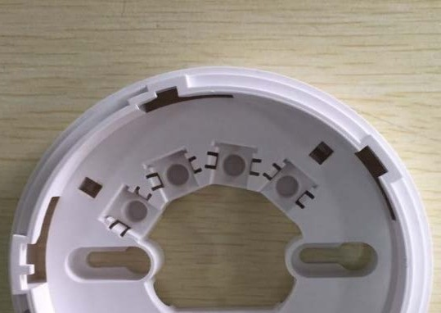

**Figure 11 - Detector Base Photo**

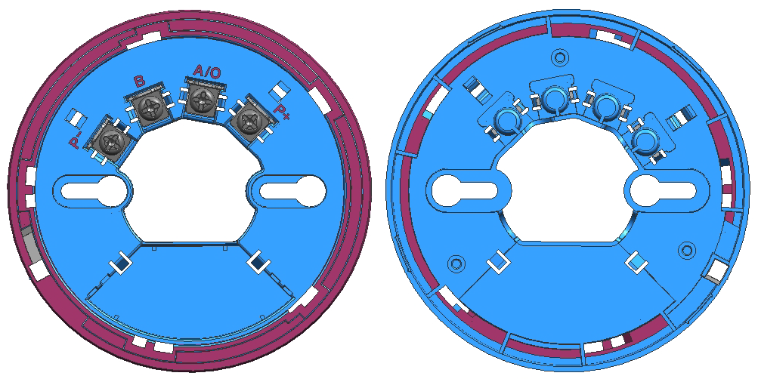

**Figure 12 - Detector Base 2D Drawings (Top Side - Left, Bottom Side – Right)**

* + 1. **Head Enclosure References**

The enclosure design of the detector head will be the same for both conventional and analogue addressable detectors.

Numens will provide the detector enclosure drawings. When changes are made, Numens will provide BPL with the revised drawings.

|  |  |
| --- | --- |
| **Drawing**  **Number** | **Description** |
| 2705001-  0001 | Smoke + Heat Top Cover |
| 2705001-  0002 | Smoke Top Cover |
| 2705001-  0003 | Heat Top Cover |

|  |  |
| --- | --- |
| 2705001-  0004 | Middle Cover |
| 2705001-  0005 | Guide Ring |
| 2705001-  0006 | Heat Sensor Guard |
| 2705001-  0007 | Detector Base |
| 2705001-  0008 | Detector Pin Socket Terminal |
| 2705001-  0009 | Base Pin Terminal |
| 2705001-  0010 | Smoke + PIR Cover |

# Table 7 - Numens Part Numbers

* + 1. **Detector Base Text**

BPL requires text to be added to the mould for the **base only**, as shown in the diagram.

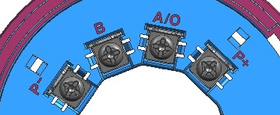

# Figure 13 - Screw Terminal Locations

The table clarifies the pin functionality for both conventional and Analogue Addressable detectors.

|  |  |  |
| --- | --- | --- |
| **Pin Label on Base Plastics** | **Function** | **Description** |
| P+ | Power in | Positive Supply pin |
| A/O | Data Tx and Open Drain Output | 3V UART |
| Open Drain Output |
| B | Data Rx | 3V UART |
| P- | GND | Ground pin |

# Table 8 - Pin-Out

This test will allow the base to be used for both Conventional and Analogue Addressable detectors.

# Base Marking Specification

The following marking specification has been taken from the EN54 standards. Each base will have the following markings printed on the base. The marking shall be visible during installation of the detector and shall be accessible during maintenance.

The markings shall not be placed on screws or other easily removable parts.

* + - 1. The model designation (type or number);
      2. Some mark(s) or code(s) (e.g. serial number or batch code), by which the manufacturer can identify, at least, the date or batch and place of manufacture, and the version number(s) of any software contained within the detector. ***This format is to be confirmed by BPL.***

# Pin Connector Specification [Updated]

The electrical pin connectors consist of a pin and a socket. The pin is mounted on the base and the socket is mounted on the detector.

A screw terminal base pin will allow wiring to a conventioal detector head.

A solder terminal base pin will allow placement on to a PCB for use by BPL for their radio base design.

See pin connector drawing 2705001-0009 (Base Pin Terminal) and socket connector drawing 2705001-0008 (Detector Pin Socket Terminal).

The 2705001-0008 socket fits to the detector heads.

The 2705001-0009 base pin fits to the passive wired base with screw terminals.

The 15-0003 base pin fits to the BPL RBU PCB. The component is through-hole to solder to the PCB. Note: This drawing is to be revised for the correct height for compatibility with the BPL radio base.

# Bill Of Materials (BOM)

A BOM will be produced by Numens listing the assembly components for each detector.

# Technical Construction File (TCF)

BPL requires a TCF to be provided by Numens for each device designed, for use during CE Marking and compliance activities.

# Review & Document Change Control Procedure

Numens must follow BPL’s review process and change control procedures. Ref: 100-PRO-0001 Procedure for Document and Record Control.

# EXTERNAL INTERFACES & TOOLS

# Detector Removal Tool

A removal tool will be developed by BPL to remove the head & radio base assembly together (the tool will not remove just the detector head from the radio base).

BPL must be notified for approval if any mechanical changes are requested by Numens, especially for external dimensions of the detectors.

# GENERAL DESIGN STANDARDS

See Bull Products Design For Excellence guidelines document, ref: 100-STD-0001. All Bull Products developments must follow these guidelines.

# DETECTOR PROTOCOL SPECIFICATION

# Introduction

The remote unit (RU) consists of two independent parts which are mechanically and electronically connected to each other, these are the radio base and the attachable element (detector/actuator, etc..). It is required to have a communication interface between these two parts as important information needs to be shared between the two. The communication is controlled by the radio base which is considered to be the master of the process. The attached element is the slave.

The communication between the radio base and the attached element is performed via two wires (pins 3 & 6 of the connecting interface) which will act as CMOS Rx and Tx lines of the UART (Direct UART from the microcontroller).

A set of commands are needed between the radio base and the attached element. The scope of this document is to describe the operation of the interrupt and wake-up mechanism of the system, the general syntax of the communication protocol and the set of commands used for data interchange. The software should follow coding standards required by EN54.

# Operation of the Interface

In normal situation, i.e. no communication between two units, Tx lines should configured as outputs and kept high, while Rx lines should be configured as inputs, pulled-down by a weak pull-down resistor on their corresponding Rx lines ( ≥ 3 MΩ). By default, each Rx line should be configured as an interrupt line, preferably triggered by the falling edge, and the UARTs on both units should be disabled. If dedicated Rx UART pins cannot be re-configured as inputs with associated interrupts, then 2 pins should be used instead – One for Rx and the other for the falling edge interrupt. So by default both lines should be high.

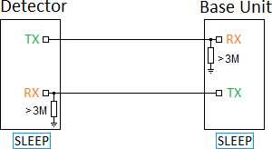

# Figure 14 - Both Units in Sleep

Once one unit wants to get attention of the other, it should pull down its Tx line for 20 ms. The other unit should wake up, check if its Rx line remains low for at least 10 ms (debouncing time). If this was not the case, it should ignore the wakeup call and go back to sleep. Any further attempts to wake the device up needs to start from the beginning.

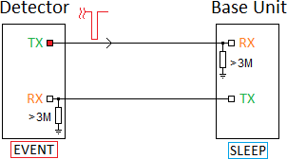

# Figure 15 - Detector gets the attention of the Base

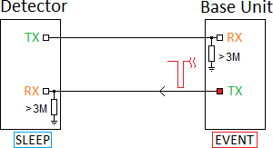

**Figure 16 - Base gets the attention of the Detector**

If the Rx line remains low for a debouncing time of 10 ms, the unit should set a time-off timer for 20 ms, and wait for the Rx line to become high again – If it becomes high before the time-off timer expires, UART is set up as well as another time-off timer interval of 20 ms and the units should start communicating. If the time-off timer expires first, the unit should go into sleep again and the process starts from the beginning.

If the Rx line remains low after the debouncing time of 10 ms, the unit should set a time-off timer for 20 ms, and wait for the Rx line to become high again – If the time-off timer expires first, there is a possibility that the unit is either detached or lost the power. If this is detected by the base unit (i.e. the detector is removed), it should start the procedure of creating a fault report. If this is detected by the detector (i.e. the base is removed), it should log the event and go back to the idle mode.

Once UART is enabled, the time-off timer (20 ms) is re-initiated every time some byte is received or transmitted. This should provide automatic end of communication 20 ms after it stops. When the detector is in pre-alarm state, this time-off timer is disabled.

Once UARTs (in both units) are configured, units should start communicating. Master unit should start sending data via Tx pin. Failure to receive acknowledgement or receive a reply will trigger the time-off timer and the unit will be forced back to sleep. Similarly, with the slave, failure to receive any command will cause its timer to send the unit into sleep.

The communication is based on message packets/commands which will be defined on this document. The Radio base unit is the Master unit and will poll information from the detector (Slave) whenever necessary.

Each command should be acknowledged by the other end. When the command is to read some data from the other unit, the acknowledgement is the message with the requested data. However, if the command is of the “write-only”, then it needs to be acknowledged after the command has been executed successfully with “OK” as the response. If the command is not recognised or not part of the protocol, the response should be “ERROR”.

Once the units are finished with communications, they can either go in idle/inactive state for time- off timer of 20 ms, or send a specific command for the other unit go to sleep. In the latter case, the other side will acknowledge it and after that, both units can go to sleep. Any further communications shall start the beginning of this process.

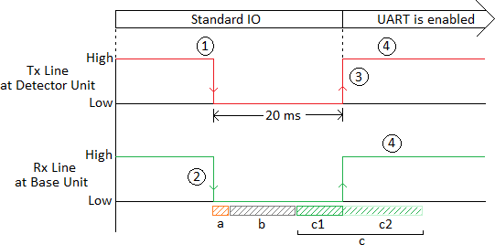

# Figure 17 - Interaction between Base and Detector.

**a) wake-up delay, b) debouncing time of 10 ms, c) c=c1+c2 time-off time set for waiting for the rising of the originator’s Tx line.**

From Figure 17

1 – The Detector starts the sequence by setting its Tx line Low for 20 ms.

2 – The Rx line at the Base unit is detected low. This state should be present for at least 10 ms. Once the 10 ms has expired, the Base waits further 20 ms for this line to be pulled-high by the Detector. 3 – The Tx line is pulled high by the detector before the 20 ms time-off timer expires.

4- The cycle is completed and both units enable their UARTs.

# Base Waking up Detector

In this scenario, the base unit generates the wake-up sequence as described above (section 2). Once the sequence is completed, the base unit sends a command to the detector. The detector handles the command and produces a reply.

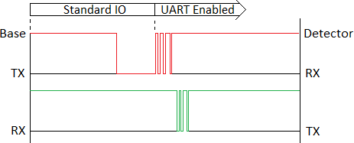

# Detector Waking up Base

In this scenario, the detector generates the wake-up sequence as described above (section 2). The wake-up sequence is triggered from the detector when an event is to be reported back to the base, for example a smoke level is too high. After the wake-up sequence is completed, the base sends a STAT command to the detector (see section 7.9.17) as an acknowledgement to the interrupt. The detector handles the command and produces a reply.

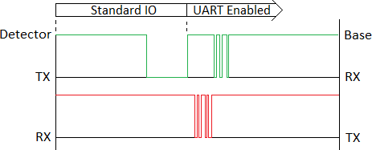

# States of Operation

The detector has three different states of operation:

|  |  |  |  |  |
| --- | --- | --- | --- | --- |
| **State** | **Operation** | **Communication Interface** | **Power (uA)** | **Description** |
| NORMAL – NO COMMS | Normal operation | disabled | Lowest (Minimum) | The detector is operating as intended. |
| NORMAL - COMMS | Normal operation | enabled | Moderate (Low) | The detector is operating as intended. Either device can talk to one another by initiating the wake- up sequence as in 7.2 |
| PRE-ALARM | The detector is in pre-alarm state | Enabled – 20ms time-out is disabled | Higher | The Upper Threshold has been reached. If the Upper Threshold is reached at the detector, it must wake-up the base-unit as described in 7.4 |

# Table 9 - States of Operation of Attached Device

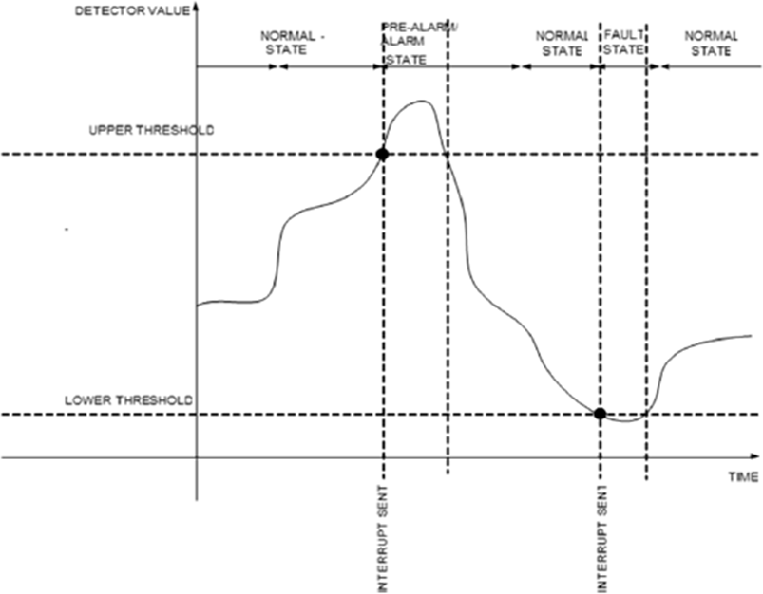

**Figure 18 Detector State changes**

There are 2 different thresholds at the detector programmable by the base as shown above – Upper and Lower. When the analogue value reaches these thresholds, the detector changes state.

# Smoke and Heat Operation

The following scenario illustrates an interrupt being triggered when the value/level is higher or equal to the Upper Threshold at the detector.

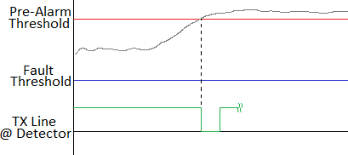

The following scenario illustrates an interrupt being triggered when the value/level is lower or equal to the Lower Threshold at the detector.

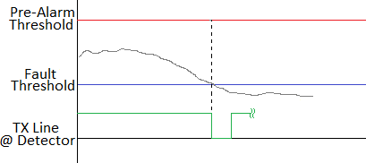

# PIR Operation

The following scenario illustrates the operation of the PIR. It starts from being disabled which means all the PIR activity is ignored (i.e. movement is ignored). In the next stage, the PIR is enabled and once it detects activity it triggers the wake-up sequence to interrupt the base unit. At this point the status value is latched to 1 which indicates that the PIR detected movement. The reset command is then sent to the detector; this will cause the status value to be reset to zero.

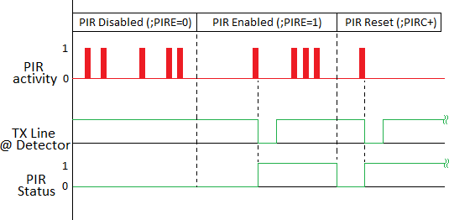

# Communication Port Settings

The characteristics of the interface is as follows:

|  |  |
| --- | --- |
| **Baud Rate** | **19,200 (or higher?)** |
| **Data Bits** | 8 |
| **Parity** | None |
| **Stop Bits** | 1 |

# Table 10 - Communication Port Settings

# General Command Syntax

All commands listed in this document must be preceded with the character “**;**” (semi-colon) and end when a carriage return character (ASCII decimal value 13 – hexadecimal 0x0D) and a line feed character (ASCII decimal value 10 – hexadecimal 0x0A) are received. All character strings used to express commands or replies are in ASCII format. An entire command sequence will have the following format:

<Prefix> <Command> <Type/Action> <Data> <CR> <LF> Where,

**<Prefix>** is the character “;” (without the quotation remarks)

**<Command>** is a 4-character long command listed in the command section of this document

**<Type/Action>** “=” for Write, “?” for Read or “+” when special command

**<Data>** is only needed when the command type is “=” (Write)

**<CR>** is the carriage return character (ASCII character decimal value 13 – hexadecimal 0x0D)

**<LF>** is the line feed character (ASCII character decimal value 10 – hexadecimal 0x0A)

Once a command is received by the device it will be processed. Once a command is processed, a response will be generated. A response will have the following format:

<Response> <CR> <LF> Where,

**<Response>** is the command specific response (depending on command) or one of the following strings (without the quotation marks):

“**OK**”, if the command is recognised and executed successfully

“**ERROR**”, if it was an unrecognised command or after an unsuccessful execution

**<CR>** is the carriage return character (ASCII character decimal value 13 – hexadecimal 0x0D)

**<LF>** is the line feed character (ASCCI character decimal value 10 – hexadecimal 0x0A)

# Error Handling

An error handling mechanism is required to avoid deadlocks occurring in the firmware and allows the detector to safely handle unrecognised commands by sending “ERROR” as the response. This will allow the detector to successfully return to normal operation and respond to any subsequent valid commands from the base.

# Example:

[COM1] - ;SENI?<CR><LF> [COM1] - ERROR<CR><LF>

The command SENI doesn’t exist in the protocol so it won’t be recognised by the detector and so it responds with ERROR as the response.

# Set of Commands

The following set of commands are used for configuring, identifying and monitoring the attached element to the radio base unit. Under normal circumstances these commands are sent by the radio base unit to the attached element also known as the attached unit.

# Serial Number

Command to read the serial number of the attached unit. This is programmed at the factory during production testing when the detector units are programmed. This serial number gives a unique identification number for each product manufactured and should be stored in EEPROM.

**Type:** Read Only

**Syntax:** ;SENU?<CR><LF>

**Reply:** <Serial_Number><CR><LF> Where:

<Serial_Number>: 12-digit number in the format YYMM-BB-SSSSS Where,

YY – Year of manufacture, beginning from current year 17 to 99 MM – Month of manufacture, range from 01 to 12

BB - Batch number of the detector with range of 01 to 31

SSSSS - Serial number of the detector with range of 00001 to 65535

# Example:

**For a detector manufactured in May 2018 under the 1st batch, the serial no will be as below**

[COM1] - ;SENU?<CR><LF> [COM1] – 1805-01-00001<CR><LF

# Software Information

Command to read the software information of the attached unit. The first part of the reply is the firmware version and the second part is the date of the firmware.

**Type:** Read Only

**Syntax:** ;I9SI?<CR><LF>

**Reply:** <Version_Number>,<Date><CR><LF> Where:

<Version_Number>: String in the format **ab.cd.ef** where a, b, c, d, e and f are digits from 0 to 9

<Date>: String in the format dd/mm/yy where dd is day (1-31), mm is month (1-12) and yy is year (16-99)

**Default:** N/A

# Example:

[COM1] - ;I9SI?<CR><LF>

[COM1] - 01.00.00,03/05/16<CR><LF>

# Type of Device

Command to identify the type of device the attached unit is. The returned value is the decimal representation of an 11-bits unsigned value as shown in the table below. Each bit represents a device type. A 1 (logic one) denotes that the device is present, a 0 (logic zero) means the device is not. The combination of devices is also valid, for instance, the bit for the smoke can be enabled in combination with the bit for heat, this means the attached element is a multi-sensor smoke+heat detector.

bit 10 bit 0

|  |  |  |  |  |  |  |  |  |  |  |  |  |
| --- | --- | --- | --- | --- | --- | --- | --- | --- | --- | --- | --- | --- |
| Type of device | spare | spare | spare | io | cp | beacon | sounder | pir | co | heat | smoke | Value (Dec) |
| Not Define/Unknown | 0 | 0 | 0 | 0 | 0 | 0 | 0 | 0 | 0 | 0 | 0 | 0 |
| Smoke | 0 | 0 | 0 | 0 | 0 | 0 | 0 | 0 | 0 | 0 | 1 | 1 |
| Heat | 0 | 0 | 0 | 0 | 0 | 0 | 0 | 0 | 0 | 1 | 0 | 2 |
| Smoke+Heat | 0 | 0 | 0 | 0 | 0 | 0 | 0 | 0 | 0 | 1 | 1 | 3 |
| Smoke+PIR | 0 | 0 | 0 | 0 | 0 | 0 | 0 | 1 | 0 | 0 | 1 | 9 |
| Heat+PIR | 0 | 0 | 0 | 0 | 0 | 0 | 0 | 1 | 0 | 1 | 0 | 10 |
| Smoke+Heat+PIR | 0 | 0 | 0 | 0 | 0 | 0 | 0 | 1 | 0 | 1 | 1 | 11 |
| Call Point | 0 | 0 | 0 | 0 | 1 | 0 | 0 | 0 | 0 | 0 | 0 | 64 |
| Call Point+PIR | 0 | 0 | 0 | 0 | 1 | 0 | 0 | 1 | 0 | 0 | 0 | 72 |
| … (etc) | … | … | … | … | … | … | … | … | … | … | … | … |
| No type detected (nothing attached) | 1 | 1 | 1 | 1 | 1 | 1 | 1 | 1 | 1 | 1 | 1 | 2047 |

# Table 11 – Type of Devices

**Type:** Read Only

**Syntax:** ;DETY?<CR><LF>

**Reply:** <Type_Of_Device><CR><LF> Where:

<Type_Of_Device>: Decimal value from 0 to 2047 which represents the device type.

**Default:** Depending on device type. If 0, it means there is an error.

# Example:

[COM1] - ;DETY?<CR><LF> [COM1] - 9<CR><LF>

*Note: Reply 9 indicates it is a multi-sensor device smoke+PIR combination.*

# Class of Device

Command to read the class of the attached unit (previously identified using command 7.9.3). The returned value is the decimal representation of a 4-bits unsigned value as shown in the following tables. If the returned value is zero it indicates that there is no device connected to the base unit and this can be considered as an error. This information generally covers the operating class of the device, type of mounting, colour or other additional details. This information is “type” dependant, which means that it only applies for the specific type of device given in Table 11s.

|  |  |  |  |  |  |  |
| --- | --- | --- | --- | --- | --- | --- |
| bit 4 | bit 3 |  |  | bit 0 |  |  |
|  | Class | | | |  | |
| smoke |  |  |  |  | Description | Value (Dec) |
| 1 | 0 | 0 | 0 | 1 | Single IR | 1 |
|  | 0 | 0 | 1 | 0 | Dual IR+Blue | 2 |

**Table 12 - Smoke detector class**

|  |  |  |  |  |  |  |  |
| --- | --- | --- | --- | --- | --- | --- | --- |
| bit 7 | bit 4 | bit 3 |  |  | bit 0 |  |  |
|  | | Class | | | |  | |
| pir | smoke |  |  |  |  | Description | Value (Dec) |
| 1 | 1 | 0 | 0 | 0 | 1 | Single IR + PIR | 1 |
|  | | 0 | 0 | 1 | 0 | Dual IR+Blue + PIR | 2 |

**Table 13 - Smoke detector + PIR class**

|  |  |  |  |  |  |  |
| --- | --- | --- | --- | --- | --- | --- |
| bit 5 | bit 3 |  |  | bit 0 |  |  |
|  | Class | | | |  | |
| heat |  |  |  |  | Description | Value (Dec) |
| 1 | 0 | 0 | 0 | 1 | A1R | 1 |

|  |  |  |  |  |  |
| --- | --- | --- | --- | --- | --- |
| 0 | 0 | 1 | 0 | B | 2 |

**Table 14 - Heat detector class**

|  |  |  |  |  |  |  |  |
| --- | --- | --- | --- | --- | --- | --- | --- |
| bit 5 | bit 4 | bit 3 |  |  | bit 0 |  |  |
|  | | Class | | | |  | |
| heat | smoke |  |  |  |  | Description | Value (Dec) |
| 1 | 1 | 0 | 0 | 0 | 1 | Smoke + Heat sensor A1R | 1 |
|  | | 0 | 0 | 1 | 1 | Smoke + Heat sensor B | 2 |

**Table 15 – Smoke + Heat detector class**

**Type:** Read Only

**Syntax:** ;DECL?<CR><LF>

**Reply:** <Class_Of_Device><CR><LF> Where:

<Class_Of_Device>: Decimal value from 0 to 15 which represents the class of the device

**Default:** Depending on device type. If 0, it means there is an error.

# Example:

[COM1] - ;DECL?<CR><LF> [COM1] – 2<CR><LF>

# Type of Device and Class

Read only command to identify the device type and class in one single message. The reply is a coma separated string which contains both values.

**Type:** Read Only

**Syntax:** ;DTAC?<CR><LF>

**Reply:** <Type_Of_Device>,<Class_Of_Device><CR><LF> Where:

<Type_Of_Device>: Decimal value from 0 to 2047 which represents the device type.

<Class_Of_Device>: Decimal value from 0 to 15 which represents the class of the device

**Default:** Depending on device type. If 0,0 is returned it indicates there is an error.

# Example 1:

[COM1] - ;DTAC?<CR><LF> [COM1] – 3,4<CR><LF>

*Note: This reply indicates it is a multi-sensor smoke+Heat and that only the heat (A1R) part is enabled.*

# Example 2:

[COM1] - ;DTAC?<CR><LF> [COM1] – 9,1<CR><LF>

*Note: This reply indicates it is a multi-sensor smoke+PIR and that optical sensor is single IR. d*

# Enable / Disable Sensor

This command is to enable and disable individual sensors such as smoke, heat or any other sensor in the future such as detector types listed in Table 16 based on Table 11. This is especially useful for a multi-sensor detector such as smoke + heat detector where one can turn off the smoke sensor only if during installation the detector needs to behave as a Heat only detector.

|  |  |
| --- | --- |
| **Sensor Type** | **ID** |
| smoke | 01 |
| heat | 02 |
| co | 03 |
| pir | 04 |
| sounder | 05 |
| beacon | 06 |
| cp | 07 |
| io | 08 |
| spare 1 | 09 |
| spare 2 | 10 |
| spare 3 | 11 |

# Table 16 Sensor Types and IDs

**Type:** Read and Write

# Syntax:

*Read - ;EDXX*? <CR><LF>

*Reply*: <Value>

*Write* - ;*EDXX* = <Value><CR><LF>

Where:

<Value>: decimal value either 0 for disable or 1 for enable.

<XX>: Sensor Id in the format ## (See table above)

**Default:** Value = 1 (All sensors are enabled from factory, depending on the type of detector. For example, a Smoke+Heat detector shall have IDs 01-Smoke and 02-Heat set to 1).

**Example 1: Read Smoke sensor status** [COM1] - ;ED01?<CR><LF> [COM1] – 1<CR><LF>

**Example 2: Disable Heat sensor** [COM1] - ;ED02=0<CR><LF> [COM1] – OK<CR><LF>

# Example 3: Error/Sensor ID for the Detector Type

*If the below command to disable the Heat sensor was sent to a Smoke + PIR detector type*

[COM1] - ;ED02=0<CR><LF>

*The response should be as follows, as per error handling techniques in section* *7.8*

[COM1] – ERROR<CR><LF>

# Smoke Upper Threshold

This command is for configuring the Upper Threshold value at the smoke detector. This value is used to determine if the smoke detector is in pre-alarm condition.

**Type:** Read or Write

**Syntax:**

*Read* - ;STH1?<CR><LF>

*Write* - ;STH1=<Value><CR><LF>

Where:

<Value>: decimal value between 0 to 99.

**Default:** TBD

**Note:** This value must be store in non-volatile memory such as EEPROM and the factory default value is 45.

# Example 1:

[COM1] - ;STH1?<CR><LF> [COM1] – 55<CR><LF>

# Example 2:

[COM1] - ;STH1=57<CR><LF> [COM1] – OK<CR><LF>

# Smoke Lower Threshold

This command is for configuring the Lower Threshold value at the smoke detector. This threshold is used to determine if there is a fault with the sensor element itself as the value reported back is lower than a level considered to be as normal. If the threshold is set to zero then this feature is disabled which means it will never trigger.

**Type:** Read or Write

**Syntax:**

*Read* - ;STH0?<CR><LF>

*Write* - ;STH0=<Value><CR><LF>

Where:

<Value>: decimal value between 0 to 99.

**Default:** 0

**Note:** This value must be store in non-volatile memory such as EEPROM and the default value is 10.

# Example 1:

[COM1] - ;STH0?<CR><LF> [COM1] – 0<CR><LF>

# Example 2:

[COM1] - ;STH0=10<CR><LF> [COM1] – OK<CR><LF>

# Heat Upper Threshold

This command is for configuring the Upper Threshold value at the heat detector. This value is used to determine if the heat detector is in pre-alarm condition.

**Type:** Read or Write

**Syntax:**

*Read* - ;HTH1?<CR><LF>

*Write* - ;HTH1=<Value><CR><LF>

Where:

<Value>: decimal value between 0 to 99.

**Default:** TBD

**Note:** This value must be store in non-volatile memory such as EEPROM and the default value for A1R is 45 and for class B it is 65.

# Example 1:

[COM1] - ;HTH1?<CR><LF> [COM1] – 45<CR><LF>

# Example 2:

[COM1] - ;HTH1=50<CR><LF> [COM1] – OK<CR><LF>

# Heat Lower Threshold

This command is for configuring the Lower Threshold value at the heat detector. This threshold is used to determine if there is a fault with the sensor element itself as the value reported back is lower than a level considered to be as normal. If the threshold is set to zero then this feature is disabled which means it will never trigger.

**Type:** Read or Write

**Syntax:**

*Read* - ;HTH0?<CR><LF>

*Write* - ;HTH0=<Value><CR><LF>

Where:

<Value>: decimal value between 0 to 99.

**Default:** 0

**Note:** This value must be store in non-volatile memory such as EEPROM and the default value is 10.

# Example 1:

[COM1] - ;HTH0?<CR><LF> [COM1] – 0<CR><LF>

# Example 2:

[COM1] - ;HTH0=10<CR><LF> [COM1] – OK<CR><LF>

# Smoke Analogue Value

Command to read the current analogue value of the optical detector.

**Type:** Read Only

**Syntax:** ;SVAL?<CR><LF>

Reply: <Smoke_Analogue_Value><CR><LF> Where:

<Smoke_Analogue_Value>: decimal value between 0 to 99.

**Default:** TBD

**Note:** This value must be store in non-volatile memory such as EEPROM.

# Example:

[COM1] - ;SVAL?<CR><LF> [COM1] – 23<CR><LF>

# Heat Analogue Value

Command to read the current analogue value of the heat detector.

**Type:** Read Only

**Syntax:** ;HVAL?<CR><LF>

Reply: <Heat_Analogue_Value><CR><LF> Where:

<Heat_Analogue_Value>: decimal value between 0 to 99.

**Default:** TBD

**Note:** This value must be store in non-volatile memory such as EEPROM.

# Example:

[COM1] - ;HVAL?<CR><LF> [COM1] – 23<CR><LF>

# PIR Status

Command to read the last latched status value of the PIR detector. For example, if the PIR sensor operation is enabled and at some point after that it detects some movement then the status should reflect this as 1.

**Type:** Read Only

**Syntax:** ;PIRS?<CR><LF>

Reply: <PIR_Status><CR><LF> Where:

<PIR_Status>: 0 or 1.

0: has not been activated (i.e. No movement detected) 1: activated (i.e. Movement detected)

**Default:** 0

# Example:

[COM1] - ;PIRS?<CR><LF> [COM1] – 0<CR><LF>

# PIR Enable Operation

Command to control the operation of the PIR sensor. The PIR can be disabled which means it does not operate therefore it does not trigger any wake-up sequence to inform the base unit.

**Type:** Read or Write

**Syntax:**

*Read* - ;PIRE?<CR><LF>

*Write* - ;PIRE=<Value><CR><LF>

Where:

<Value>: 0 or 1.

1. - PIR operation is Disabled (i.e. Ignores PIR therefore does not trigger any event)
2. - PIR is Enabled (i.e. It allows to trigger events)

**Default:** 0 (By default the PIR operation is disabled)

# Example 1:

[COM1] - ;PIRE?<CR><LF>

[COM1] – 0<CR><LF> *Note: PIR is disabled*

# Example 2:

[COM1] – ;PIRE=1<CR><LF>

[COM1] – OK<CR><LF> *Note: PIR is enabled*

# PIR Reset Operation

Command to reset the operation of the PIR sensor. Use this command to reset the status value of the PIR (Command 6.12) to zero.

**Type:** Special

**Syntax:** ;PIRC+<CR><LF>

**Default:** TBD

# Example:

[COM1] - ;PIRC+<CR><LF> [COM1] – OK<CR><LF>

# Indicator Control

Command to control the operation of the indicator LED of the attached unit. This LED can be switch On or Off at any time and the current status can be requested back.

**Type:** Read or Write

**Syntax:**

*Read* - ;ILED?<CR><LF>

*Write* - ;ILED=<Value><CR><LF>

Where:

<Value>: 0 or 1. 0: LED is Off or 1: LED is On

**Default:** 0

# Example 1:

[COM1] - ;ILED?<CR><LF>

[COM1] – 0<CR><LF> *Note: LED is Off*

# Example 2:

[COM1] - ;ILED=1<CR><LF>

[COM1] – OK<CR><LF> *Note: LED is switch On*

# Detector Status – with type of device

Read only command to identify the status of the detector and the type of sensor that raised the event/interrupt in one single message. The reply is a coma separated string which contains both values.

**Type:** Read Only

**Syntax:** ;STAT?<CR><LF>

**Reply:** <Detector_State>,<Type_Of_Device><CR><LF> Where:

< Detector_State >: Decimal value from 0 to 9 which give the status of the detector.

< Type_Of_Device>: Decimal value from 0 to 2047 which gives the type of sensor that raised the event.

Where,

**Detector_State** is

1. – Normal
2. – Threshold Event (This event occurs when either of the Upper or Lower thresholds are reached/crossed by any sensor.

**Type_Of_Device** is the same as previously defined in Table 11

For eg:

1. – Smoke
2. – Heat
3. – Smoke+Heat
4. - PIR

# Example 1:

[COM1] - ;STAT?<CR><LF> [COM1] – 1,1 <CR><LF>

*Note: This reply indicates that smoke sensor has crossed the threshold and raised the event.*

# Example 2:

[COM1] - ;STAT?<CR><LF> [COM1] – 1,8 <CR><LF>

*Note: This reply indicates that the PIR has raised the interrupt event.*

# Optical Chamber Status

Command to enquiry about the operational status of the optical chamber. This command is used to report any possible dirt or problems which could affect the performance of the detector.

**Type:** Read Only

**Syntax:** ;OCS1?<CR><LF>

Reply: <Optical_Chamber_Status><CR><LF> Where:

<Optical_Chamber_Status>: 0 to 3.

1. – Optical Chamber Normal
2. – Dirt Low Level
3. – Dirt Med Level
4. – Faulty

**Default:** 0

# Example:

[COM1] - ;OCS1?<CR><LF> [COM1] – 0<CR><LF>

# Switch Control

Command to control the operation of the detector. Use this command to stop operation of the detector entirely.

**Type:** Read or Write

**Syntax:**

*Read* - ;OPEC?<CR><LF>

*Write* - ;OPEC=<Value><CR><LF>

Where:

<Value>: 0 or 1.

* + - 1. – Detector is switched OFF
      2. – Detector is switched ON

**Default:** 1

# Example 1:

[COM1] - ;OPEC?<CR><LF> [COM1] – 1<CR><LF>

# Example 2:

[COM1] - ;OPEC=0<CR><LF>

[COM1] – OK<CR><LF> *Note: The detector is switch-off completely*

# Identification Number

Command to configure a unique number to the detector which could be used as an indication if the device was disconnected at any point. This value must be store in RAM and reset to zero on power up.

**Type:** Read or Write

**Syntax:**

*Read* - ;IDNU?<CR><LF>

*Write* - ;IDNU=<Value><CR><LF>

Where:

<Value>: 4-digit representation of a hexadecimal number. From 0001 to FFFF.

**Default:** 0000

# Example 1:

[COM1] - ;IDNU?<CR><LF>

[COM1] – 0000<CR><LF> *Note: The detector has been switched ON recently*

# Example 2:

[COM1] - ;IDNU=1A3E<CR><LF>

[COM1] – OK<CR><LF> *Note: The detector has been assigned a new Id which is kept in RAM*

# Reset Source

Command to identify any possible reset source of the detector. By default, the first and logical reset source on power-up of the attached detector is the power-on reset source. After this source is identified the base unit is in responsible for resetting this value.

**Type:** Read or Write

**Syntax:**

*Read* - ;DRSO?<CR><LF>

*Write* - ;DRSO=<Value><CR><LF>

Where:

<Value>: 0 to 4

* + - 1. – No Reset
      2. – Power-On Reset
      3. – Watchdog Timer Reset
      4. – Brown-out Reset

**Default:** 1

# Example 1:

[COM1] - ;DRSO?<CR><LF>

[COM1] – 1<CR><LF> *Note: The detector has been switched ON recently, Power-On Reset*

# Example 2:

[COM1] - ;DRSO=0<CR><LF>

[COM1] – OK<CR><LF> *Note: Reset source has been cleared*

# Disable Communications

Command to disable the communication interface. The UART CMOS module is disabled, no more commands are intended from the Base unit to the Detector.

**Type:** Special

**Syntax:** ;CXTO+<CR><LF>

**Default:** N/A

# Example:

[COM1] - ;CXTO+<CR><LF> [COM1] – OK<CR><LF>

# Detector Branding Id [New Command]

Command to read or write a value which identifies the system’s manufacturer. The default value is 1.

**Type:** Read and Write

# Syntax:

Read - ;DBID?<CR><LF>

Reply: <Value>

Write - ;DBID=<Value><CR><LF>

# Where:

<Value>: decimal value from 1 to 255 in the format ###. Default Value: 1 (Factory default for all detectors)

**Note:** The value is stored in EEPROM and this is achieved after approximately 800ms.

**Example 1**: Read Detector’s Branding Id. (Default is 1) Tx> ;DBID?<CR><LF>

Rx< 001<CR><LF>

**Example 2**: Write Detector’s Branding Id to 2. The value is stored in EEPROM. If the detector is switched Off and On again the value is kept as 2.

Tx> ;DBID=002<CR><LF> Rx< OK<CR><LF>

**Example 3**: Read Detector’s Branding Id. (After >800ms) Tx> ;DBID?<CR><LF>

Rx< 002<CR><LF>

# 8 REFERENCES

[1] 1000-DBA-0003-02 PIR Interface requirements